**The legal system of Bangladesh is based on a common law system that has been influenced by British law, as the country was once part of the British Empire. It combines aspects of customary law, Islamic law, and statutory law enacted by the Parliament of Bangladesh.**

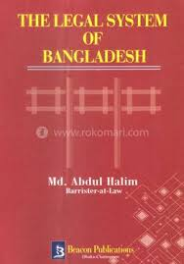

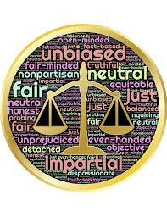

**Constitutional Law**

**Criminal Law**

**Civil Law**

**Family Law**

**Labor and Employment Law**

**Bangladesh law\Judicial system**

Penal code **Supreme court of Bangladesh**

The legal system of Bangladesh follows a **common law** system influenced by British law, with a **Constitution** that guarantees fundamental rights and the structure of governance. Its courts include the **Supreme Court**, **District Courts**, and various specialized tribunals, with the **Penal Code** and other statutes forming the basis of criminal and civil law【16†source】【17†source】.

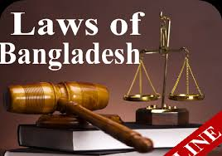

**Court system of Bangladesh**

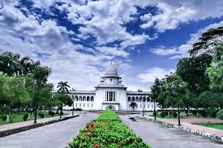

Contract law

Hindu law

Muslim law

Family Law

**Law of Bangladesh**

Bangladesh is a democratic c o

u country country. Here people give vote to

elect elect their favorite candidate

also, if anyone violate the law

they will be under the punish-

ment of Bangladesh law.

